Seoul Searching in South Korea

By: Jackie

I spent 2 weeks of solo traveling in South Korea in August 2016. The land of K-POP and K-Dramas gave me plenty of places to explore. In Seoul, the capital of South Korea and one of the safest cities in the world, I spent a lot of my time eating at cool themed cafes and trying out various Korean cuisine. I enjoyed the spin on foods that I enjoy back in the US, such as ChiMek (fried chicken and beer) and Korean BBQ, which as a Southerner I had to try. The food is generally spicier than what you would find in the US so be warned. It’s easy enough to find a convenience store and buy some cheap ramen and snacks. The place where I stayed at had free ramen and rice included with the stay so it helped to save on food costs. I stayed in the Dongdaemun area of Seoul and it was pretty affordable to stay in an AirBnB, but hostels are also affordable options. It’s more expensive to stay in place like Gangnam so make sure you do some searching if you are on a budget. I spent a lot of time in Seoul, but I took the opportunity to join a cultural tour and finding an affordable flight to Jeju island. I recommend learning a few Korean phrases before going to South Korea. Although most people had some level of English proficiency, if you want to get the most out of your experience you should probably study up on phrases for food, shopping, and travel. YouTube has plenty of resources for this. 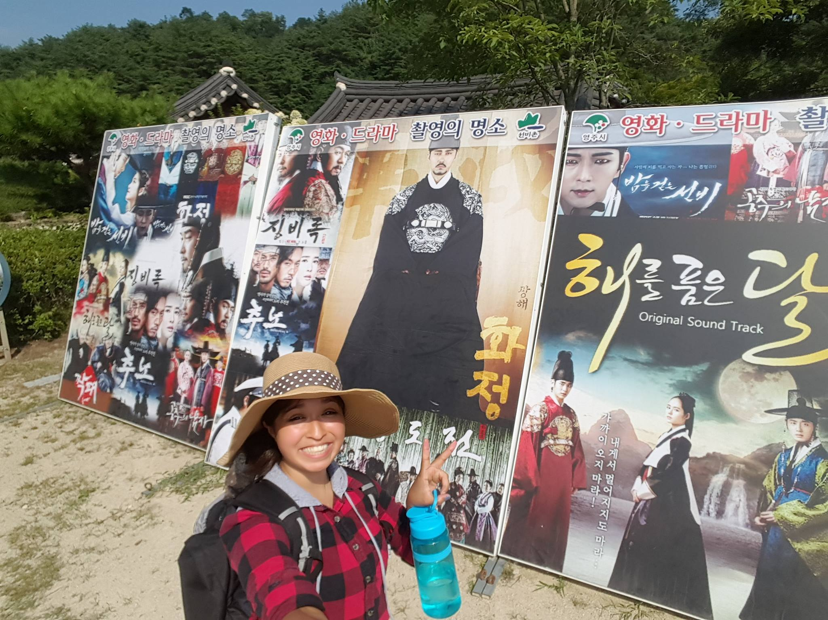

My 3 days in Poland

By: Jackie

I travelled to Gdansk, Poland in November 2017 to see an international friendly between Poland and Mexico. The entire 3 days I spent less than £300 on travel, food, accommodation, and my ticket to watch the football match. Gdansk had a lot to offer, but I only had 3 days to explore so I saw what I could. Traveling around Gdansk was pretty straight forward as long as you had google maps to know where to get off. It was a bit harder to find people who spoke English, but if you ask your host where you are staying, I am sure they can point you in a good direction for food and drinks. There was a wonderful Christmas market with lots of places to get something for family and friends. I got a really cute mug from a family pottery store. Most places were nice enough to give me discounts or lower the prices if you bought another item. I even got free chocolate or an extra pastry! People I met in Poland were wonderfully nice and helpful!